Margaret Hamilton

# Background

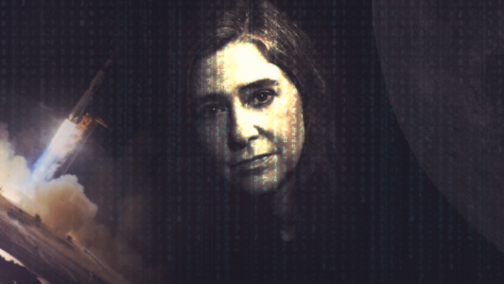Margaret Hamilton was born in Paoli, Indiana, US., in 1936. She is most widely known for developing the software that helped Neil Armstrong and Buzz Aldrin get to the moon in 1969. She was a pioneer in the field of software engineering and was among the first to coin the phrase.

She began her career studying mathematics and philosophy in Earlham College, Richmond Indiana, followed a brief stint in teaching high school mathematics, before finally taking a job at Massachusetts Institute of Technology (MIT) working under Edward Norton Lorenz predicting weather patterns and ultimately exploring chaos theory. Here she flourished, learning the ropes of computing on the LGP-30 and PDP-1, very early computer models, with little to no help but for instruction manuals. Later joining the Lincoln Laboratory and developing software for numerous projects including the U.S. Air Defense System, her success here later landed her a job developing software for NASA’s lunar landers used in the Apollo missions.

# The Apollo Missions

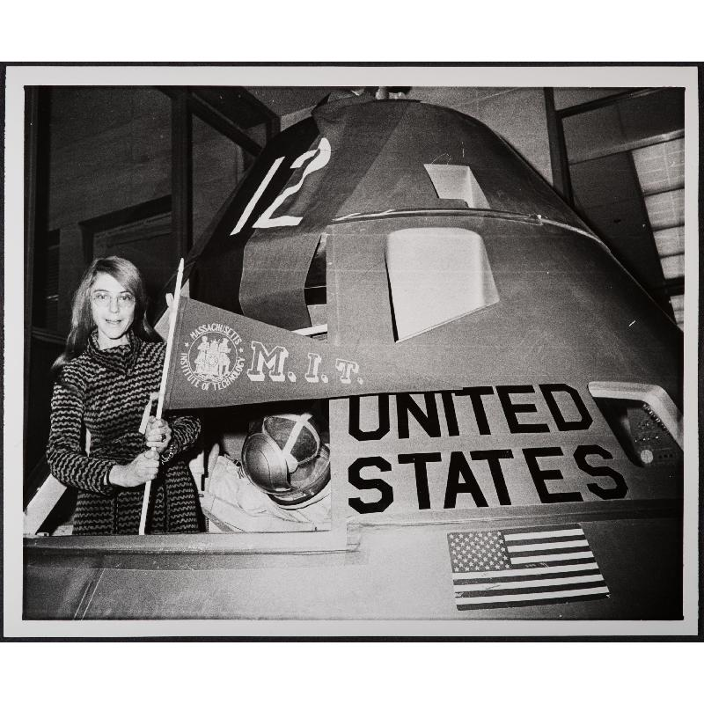Hamilton was placed in charge of developing emergency program software that identified system errors and recovered data in the event of system failure. It is said that she was placed in charge because it was thought that this software would never be used as astronauts were trained to be infallible. Her work proved to be crucial however, as an error was thrown just minutes before the landing was scheduled to take place. Buzz Aldrin accidentally flipped the rendezvous radar switch, overloading the computer. Hamilton’s software flagged the error and compensated for it, the astronauts were ultimately given the go-ahead for landing and Hamilton’s software ensured that one of the most monumental moments in human history was able to take place.

At the time computing technology was primitive and severely constrained by storage capacity. There were only 72 kilobytes of storage onboard the lunar landing module, a standard 32 gigabyte phone has 500,000 times the storage capacity. In addition to the miniscule storage capacity the software at the time could only execute tasks in a pre-determined order. This could have constrained the adaptability of the software, but Hamilton found a solution, she made her program asynchronous. She gave each task a priority level and her software ignored low-priority tasks and errors in favor of addressing more pressing issues.

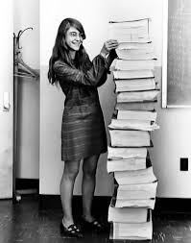Programming in the 60s was archaic and consisted of punching holes in pieces of paper called punch-cards. These cards would be fed to a room sized computer to simulate the landing of the Apollo crew on the surface on of the moon. These cards were also sent to a nearby lab where they would be threaded with copper wire; a wire through a hole acted as a 1 and a wire over a hole became a 0, such was the primitive nature of programming convention back then. In the photo above we can see the code that allowed the lander to touchdown on the moon. Now all this code can be stored in a tiny flash drive and is readily available on GitHub.

Hamilton was known for her precise approach to programming which consisted of intensive and rigorous testing of all code. She is said to have insisted that NASA conduct many more tests than they had initially scheduled to ensure that every possibility for failure was identified and mitigated. Such was her precision that NASA never identified a single bug in any of the software used in the manned Apollo missions.

# Hamilton Technologies Inc.

Hamilton left NASA in the 1970s and founded Hamilton Technologies in Cambridge, Massachusetts very close to MIT in 1986. Here she developed the Universal Systems Language (USL), a programming language “based on a preventive, development-before-the-fact philosophy that does not allow errors in the first place”. The USL took inspiration from Hamilton’s work on the Apollo missions. It differed from conventional object-oriented programming and focused on assessing the system as a whole, using “system-oriented objects”. This development-before-the-fact programming philosophy means that the developers consider the potential areas for error and mitigate these, ensuring less need for testing later in the development process while delivering the same robust and reliable software system. USL is based on three axioms **(SEE APENDIX)** of control that define the rules as such for the language. The USL comes accompanying the “001 Tool Suite”, an IDE for developing reliable software systems, models and simulations. The USL-001 has many applications across many different fields from battlefield management to banking and enterprise management systems.

# Legacy

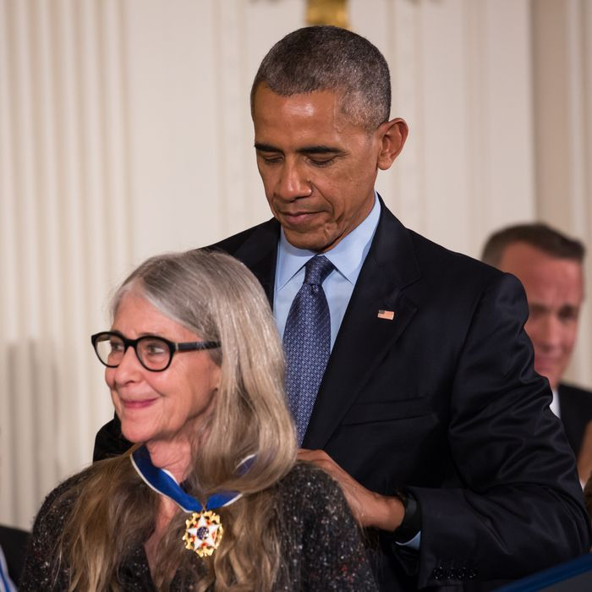In 2016 Hamilton was a recipient of the Presidential Medal of Freedom, awarded by then President Barack Obama, it is the highest honor a civilian can achieve in the U.S. This award recognizes her outstanding achievements in her field of software engineering and her contributions to man’s journey to the moon. She is now among prestigious company including Martin Luther King Jr., Mother Teresa, Rosa Parks and many more recipients of the coveted prize.

She was also honored by NASA in 2003 for her work, receiving the largest financial award that NASA had ever given at the time. Both of these awards are testimony to the lasting legacy that Hamilton has created, not only for the work in her field but inspiring a generation of young women that they can rise to the top in STEM fields. In the 1960s gender roles and stereotypes were still very antiquated, women were expected to stay at home and keep the house, Hamilton’s work and success showed women that this need not be the case and that women can thrive in STEM fields, even fields that at the time were not defined such as software engineering. Her ability to overcome the barriers in place for women at the time is truly inspiring.

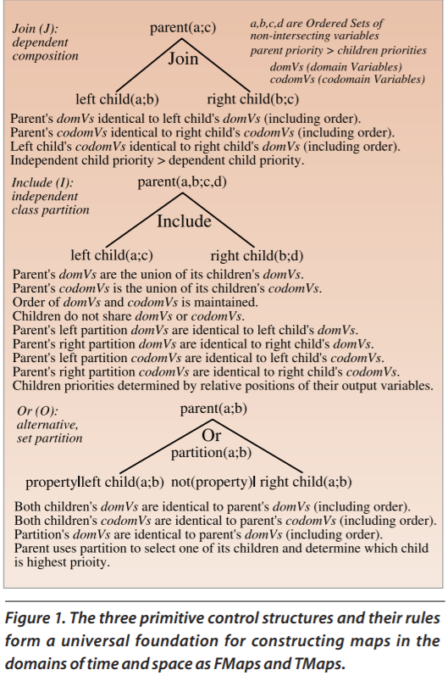**APPENDIX**

**REFERENCES**

<http://htius.com/Articles/r12ham.pdf>

<https://www.nasa.gov/feature/margaret-hamilton-apollo-software-engineer-awarded-presidential-medal-of-freedom>

<https://www.smithsonianmag.com/smithsonian-institution/margaret-hamilton-led-nasa-software-team-landed-astronauts-moon-180971575/>

<https://www.youtube.com/watch?v=kYCZPXSVvOQ>